The Grove Primary Academy

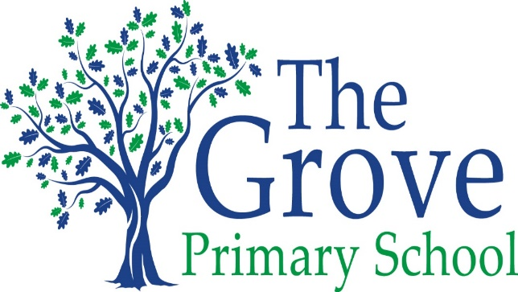
Every Child, Every Challenge, Every Day
High aspirations, Diversity, Resilience

Statement of the Intent, implementation and Impact of our Curriculum – Science

May 2020-21

The Intent, implementation and Impact of our Curriculum – Science

Intent

At the Grove we recognise that all children have a natural inquisitiveness about the world around them and about how things work. We aim to nurture and develop this to give our children a deeper understanding of their world and to prepare them for the future, where science and technology play a vital role in the world’s future prosperity. We expect that every child will achieve their full potential, no matter what their starting point is and our curriculum is driven by our school values of achievement, diversity and resilience.
We use the five areas of scientific enquiry as the starting point for all of our teaching. This enables children to build their resilience through asking their own increasingly complex questions; developing their skills in explaining what they already know and what their findings might mean as well as drawing conclusions from data they collect.
Our units are fully inclusive and carefully planned to ensure that all of our children are able to access a range of exciting and challenging experiences, which will secure and extend their individual scientific knowledge and understanding whilst nurturing a love of the subject.

Implementation

We use the National Curriculum as the starting point to provide a broad and balanced plan across the whole school. Each year group has the freedom to plan topics either as a block of learning or as regular weekly sessions, which they link closely with other curriculum areas in order to enhance the children’s subject knowledge and make their learning more meaningful. These plans are carefully monitored and cross-referenced against the National Curriculum in order to ensure full coverage and progression.
For each unit, we produce a topic overview which outlines the key areas of scientific learning, the range of enquiry skills that will be covered and a comprehensive vocabulary list specific to that topic. The children are each given this at the start of every topic and they are encouraged to refer back to it regularly in order to help consolidate their learning.
We recognise the importance of making clear links with other curriculum areas, particularly Maths, Design and Technology, ICT and English. We aim to have an annual STEM week where these links can be focused upon and deepened within each year group and across the whole school. We will draw upon links with local schools and companies which are members of the STEM ambassador scheme in order to broaden the experience for our children.
Teachers regularly assess and monitor the children’s knowledge and understanding using a variety of methods. At the start of each topic, children are given a unit assessment, the results of which are used to tailor planning to the specific needs of the children. The same assessment is used at the end of each topic to monitor the success of planning and teaching. Alongside this, children are assessed during each lesson through careful questioning and being given a range of opportunities to discuss and explain their knowledge and understanding.

Impact

We have high aspirations at The Grove and expect all children to reach at least age-related expectations or, for some, make excellent progress from individual starting points.
As Scientists, pupils at the Grove will:
- Use their natural curiosity to explore the world around them and ask questions that will allow them to deepen their knowledge and understanding of the range of topics they encounter. They will be able to record and explain their findings and their subsequent learning in a variety of different ways and to a range of audiences.
- Take pride in demonstrating a clear progression in their scientific enquiry skills as they move through their school career at the Grove.
- Use these enquiry skills in all areas of the curriculum in order to prepare them to be inquisitive and independent learners in the the next stages of their education and into adulthood.

