The Grove Primary Academy

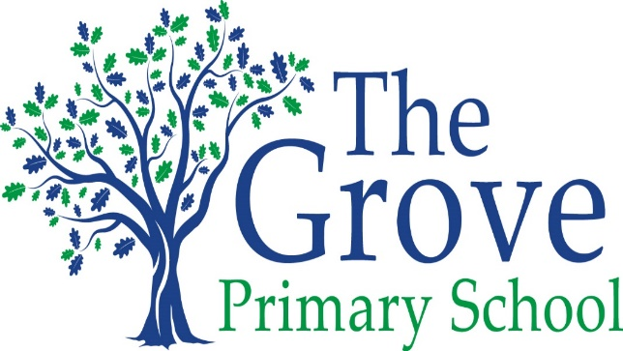
Every Child, Every Challenge, Every Day
High aspirations, Diversity, Resilience

Statement of the Intent, implementation and Impact of our Curriculum – Art

May 2020-21

The Intent, implementation and Impact of our Curriculum –RE

Intent
Through Religious Education, a Grove learner will develop an appreciation of the nature of religion and belief, and its value in the search for meaning. Children will develop the knowledge, vocabulary and skills to reflect upon and understand their own spiritual, moral and social development and cultivate a more inclusive and respectful approach to the diverse beliefs of others. Through discussion, children develop the ability to make reasoned, informed and creative responses to religious and moral issues. We have high aspirations at The Grove and expect all children to reach at least age related expectations or for some, make excellent progress from individual starting points.

Implementation
At the Grove we follow the agreed syllabus for Surrey which reflects the needs and concerns of the local area and helps children to better understand the diversity within their local community. Topics may be taught in a block or weekly, and this will vary by year group. The children develop knowledge and understanding of Christianity, and of the other principal religions and beliefs represented in Great Britain, including Judaism, Hinduism, Islam, and Buddhism. Through a combination of discrete learning opportunities and seasonal celebrations, our children experience a variety of teaching styles and approaches, which enhance the learning outcomes of the curriculum. Cross-curricular learning offers children the chance to consider religious and moral concepts and stories through different perspectives, enhancing their understanding of faith, belief and moral issues. Visits are made to local places of worship, and members of the extended school community are invited to give insight into their faith and religious practises. Year 4 have a weekly opportunity to learn more of biblical stories through the ‘Open the Book’ programme of learning offered by our local church.

Impact
Through the teaching of RE at The Grove, children will develop an awareness of the importance of belief in people’s lives and an appreciation of humanity’s diversity. They will be able to make links between their own lives and the lives of others in their community. Children will build confidence in their ability to articulate their thoughts with accuracy and to be able to discuss respectfully topics of moral, spiritual and ethical import with reference to religious beliefs and texts. They will also develop resilience in understanding that their view point may not be shared by others.

