The Grove Primary Academy

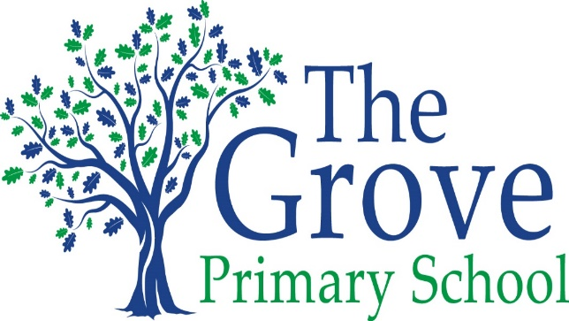
Every Child, Every Challenge, Every Day
High aspirations, Diversity, Resilience

Statement of the Intent, implementation and Impact of our Curriculum – MFL

May 2020-21

The Intent, implementation and Impact of our Curriculum – MFL

Intent
Our aims are to provide a French curriculum which is engaging for all, ambitious and stimulates the pupils’ creativity. French is the chosen modern foreign language, being taught to years 2-6 inclusive.
The learning of a foreign language provides an invaluable educational, social and cultural experience for all the children at our school. The pupils develop communication and literacy skills that are the bedrock for future language learning. They develop linguistic competence, extend their knowledge of how a language works as well as explore the similarities and differences with the English language. The children are given opportunities not only to compare British and French values and traditions but also gain an understanding and appreciation of the wider world. The school’s own set of values, which include achievement and resilience dove tail in. Teaching MFL is a vital way to enhance children’s perceptions and to promote positive attitudes towards cultural diversity as well as develop aspirational and resilient learners.

Implementation
A specialist teacher is employed to teach a foreign language at the Grove Academy. Using the National Curriculum 2014 and the KS2 Framework for Languages as a foundation, its foci are a broad and balanced curriculum based on oral, aural and written activities. We do not follow a prescribed, published scheme but have generated one that is specific to the needs of the children at The Grove. This allows us to make stronger links to the wider curriculum, English being the principal one, with key crossovers in I.T, science, geography, physical and religious education. The use of the outdoor learning environment also forms an essential part of their languages learning experience.
The children are taught on a weekly basis by the peripatetic teacher with class teachers supplementing and reinforcing the learning where possible. The children are encouraged to make use of their learning throughout the school day. The classes are all mixed ability with the lessons being structured to accommodate the needs of all the pupils. The programme of work has been written with an emphasis on the progressive development of skills which include grammar and phonetical awareness. To motivate all genders and enhance their experiences, topical themes are put into place such as The Olympics.
Parents are actively encouraged to be involved in their children’s language learning through regular bulletins, sending home of certificates and invitations to assist in special languages days.

Impact
We have high aspirations for all the pupils at the Grove, expecting then to reach at least age related expected and for some to make excellent progress. The success of the languages’ curriculum is measured in a variety of ways. The pupils are always encouraged to develop a ‘have a go’ mentality which in turn builds their self-confidence. The 2013 Programmes of study form the basis for the teacher assessments, which are in line with the school’s assessment procedures. A child friendly format is also being used by the pupils as a form of self-evaluation. Marking follows the school system, allowing children to self-assess and peer mark. Pupil voice is continuously used to monitor the children’s perception of various aspects of the subject.
We are committed to help our pupils foster a love of language learning which they progressively build upon year on year.

