The Grove Primary Academy

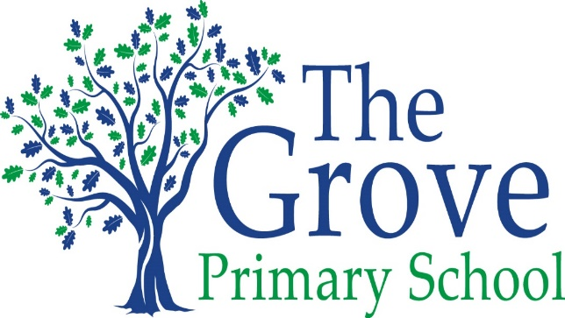
Every Child, Every Challenge, Every Day
High aspirations, Diversity, Resilience

Statement of the Intent, implementation and Impact of our Curriculum – Art

May 2020-21

The Intent, implementation and Impact of our Curriculum – Art

Intent
At The Grove, we place a great emphasis on the importance of Art and Design and we ensure that the subject is inclusive of every child. Our School values of achievement, diversity and resilience drive our curriculum. We aim for every child at The Grove to achieve their full potential in Art. We promote diversity by exposing the children to a range of artists from different eras and cultures and encourage resilience through a growth mindset. Art enables children to express themselves in a creative, imaginative manner. We intend to teach the children a skills based curriculum, with individuality and creativeness flowing through everything they do.
Implementation
The skills and knowledge that children will develop throughout each art topic are mapped across each year group and throughout the school to ensure progression. The emphasis on knowledge (colour mixing, sketching skills etc) ensures that children understand the context of the artwork, as well as the artists that they are learning about and being inspired by. We also focus on introducing a range of vocabulary to the children, this will be extended as the children move through the years. Art also enables links to other curriculum areas; for example theme days linked to history e.g. Egyptians - making Canopic jars. Art lessons occur mainly through blocks in afternoon sessions (1 to 2 hours) – with each year group having at least 3 different units per year, focusing on the knowledge and skills stated in the National Curriculum. We also cover Art units through festivals and events that take place during the year – for example every child takes part in designing their own Christmas Cards and children are able to use a wide variety of skills and resources. In addition we offer an art and crafts club afterschool that is available for every child. Here children can take part in a range of art activities each with a specific focus skill.
Impact
We have high aspirations at The Grove and expect all children to reach at least age related expectations or for some, make excellent progress from individual charting points. Children will be become creative learners, who have a web of knowledge about the great artists of the world. Creativity and uniqueness will be celebrated and children will become astute at editing and improving the pieces they have created. Through our British values we look at artists that have had an impact on Great Britain as well as events that have inspired artwork. We encourage children to have the freedom to create art and give them independence to be inspired.
In Art a grove learner will:
- Confidently record their artwork using a variety of tools.
- Articulate and evaluate not only their own art but their peers.
- Be proud of what they have created.
- Have the curiosity to continue delving into art and new skills.
- Be able to have access to a wide variety of artists and a wide variety of projects.
- Have opportunity to share their art not only with the school but with the local community.
Classroom displays reflect the children’s sense of pride in their artwork and this is also demonstrated by creative outcomes across the wider curriculum. As teachers, there will be an emphasis placed on individuality and children will be given the freedom to explore art using their imaginations. Children will have embedded the key art and design skills needed to allow them to produce inventive pieces of art.

